

**Student Name :** **Imran Ahmed**

**Student ID : BIT-23F-052**

**Semester: 3-B**

**Lab: Artificial Intelligent**

**Lab Instructor: Ma’am Aqsa**

**LAB NO: (01)**

**Lab Task 01/ (Shapes)**

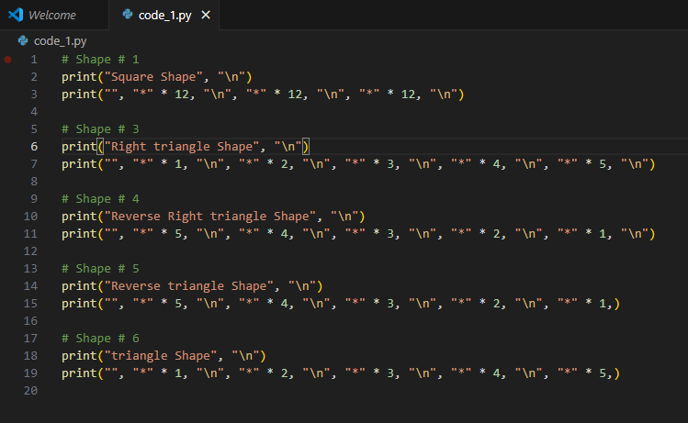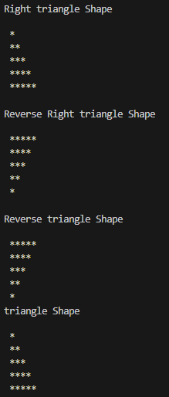

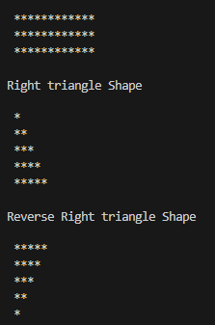

**LAB NO: (02)**

**Lab Task 01 (Data types)**

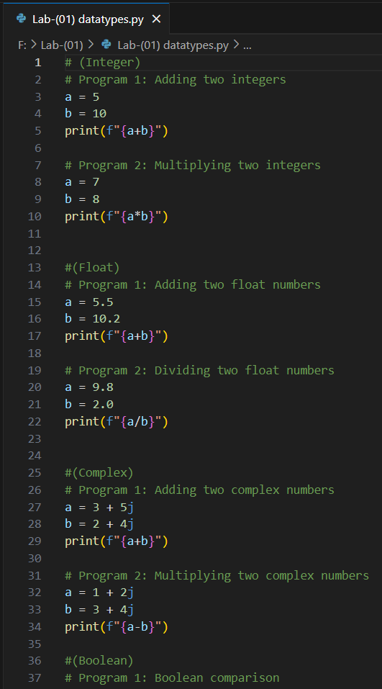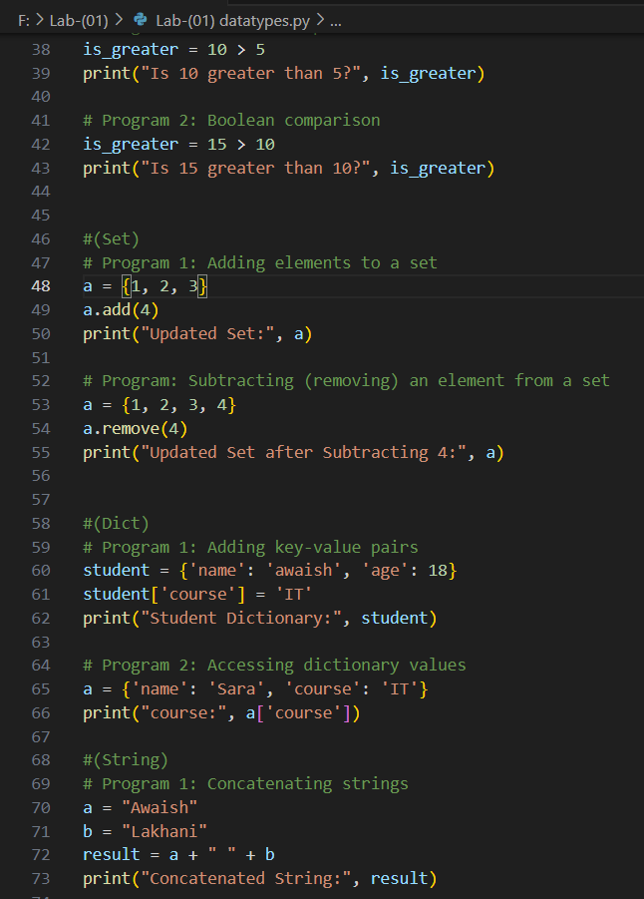

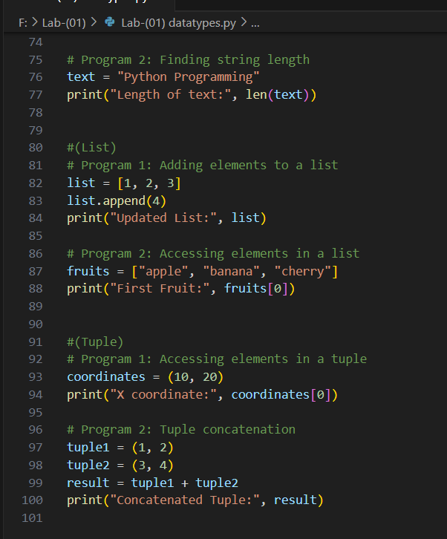

**LAB NO: (03)**

**Lab Task (01)**

